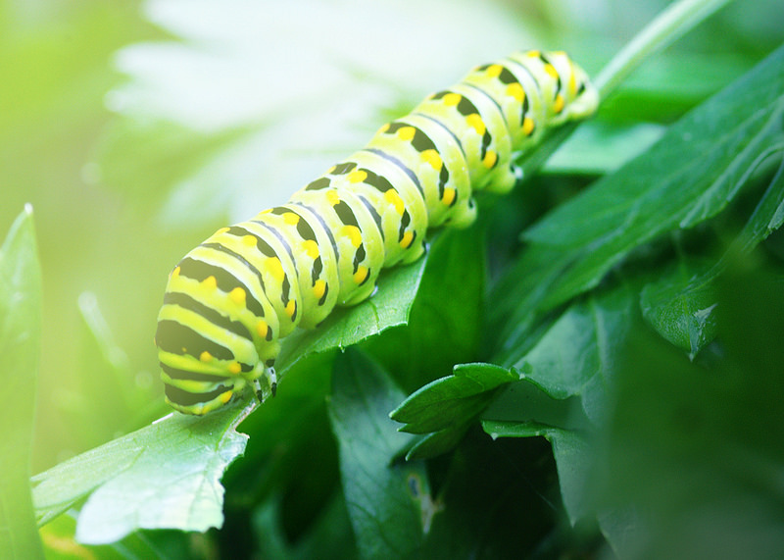
When we encounter metamorphosis in nature, it always seems effortless. No one needs to coax a caterpillar to become a butterfly. It just happens. Zip. Bam. Abracadabra.
The strange ease of natural metamorphosis is what underlies all of own dreams of transformation. It’s January now, and we’re all roughly three weeks into our new resolutions. Or our revolutions. Unlike the caterpillar, however, we don’t have an intuitive sense of how to get to where we want to be. We don’t have the luxury of just sitting back and ‘letting nature happen.’ Instead, we find ourselves struggling at every turn - to become better versions of who we already are.
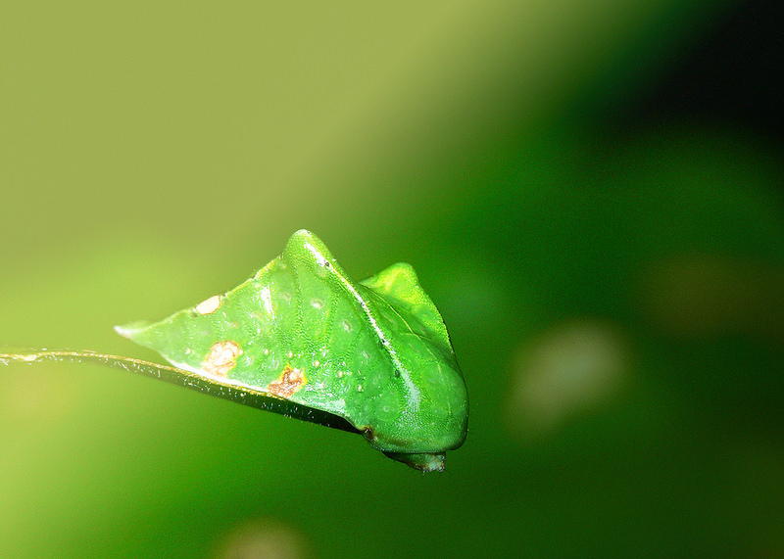
When we practice yoga, we practice metamorphosis in its most basic form. In a 60-minute Moksha sequence we can experience becoming a tree, an eagle and a cobbler (someone who mends shoes for a living). We can become still and proud as a bridge; solid and serene as a mountain overlooking the sea.
If these poses are easy for us, it is because we aren’t too attached to being one way or another. When we enter yoga class, if we are sincere in our practice, we aren’t really thinking about being human. Instead, we feel that we are muscles, skin and bone; we feel heat, tension and release; we feel effort and relaxation. In the openness of this experience we find somehow that we become something else (be it tree, eagle or cobbler): and we see that transformation always happens on its own.
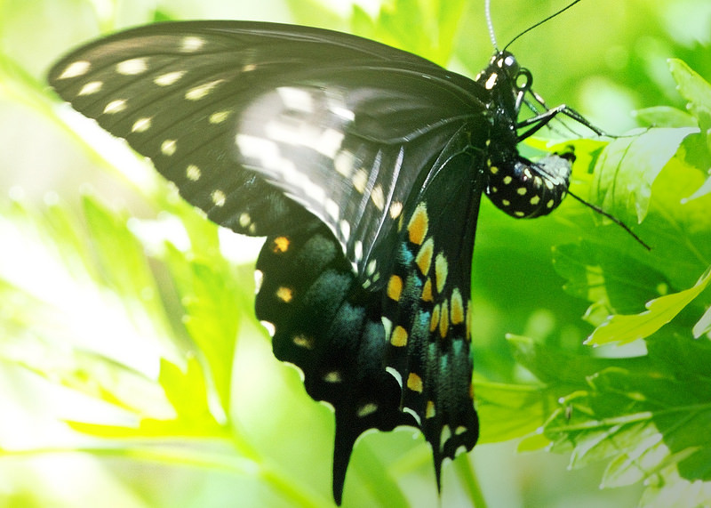
Let metamorphosis happen. If you are struggling with trying to change, you might want to bring your focus to the assumptions that bring struggle into your practice. Let go of the idea that struggle is needed for you to become who you are. You are already you. Why struggle to attain something you already have?
You Will Change When You Stop Telling Yourself:
1. “Hmph! I should be a butterfly by now. If I don’t do it now, I’ll never do it.”
2. “Charlie turned into a butterfly three weeks ago. Geez, what’s wrong with me?"
3. “My mother said I should really turn into a moth. No matter how hard I try, though, I just keep becoming a butterfly."
4. “Dear God: I totally trust you and this so-called ‘total change’ I’m undergoing right now, but can I just keep my torso? I love my torso."
5. “Man, the second I turn into a butterfly - it’ll be smooth sailing from there. Everything will be better once that happens."
6. “If I can just become a butterfly, then I’ll be worthy of love and belonging."
7. “What are all these butterflies doing around my house? I hate them!"
8. “I just need to be really hard on myself. The harder I am, the faster I’ll become a butterfly."
9. “Am I doing this right? Can someone tell me how to do this?"
10. “Me, a butterfly? Not in a million years!"
When we trust the process, we rely on the energy and wisdom of the world to lead us to the places where we want to be. The secret is, metamorphosis is easy - we just have to let go of our own resistance. And when we do, we might just find that we’ve changed more than we ever thought possible. That it was strange, and challenging, but also - perfectly simple.
Relax. It’s already happening.
- M. C. J.
[ Images from Flickr: I, II, III and IV]

